Do you feel like summer should get a speeding ticket? We agree! It’s gone by way too fast!
But we aren’t going to “Fall” without a fight! The Ellis County Historical Society is sending summer out with a BIG BANG as we close our exhibit of the Sternberg Firearms Collection on Saturday, September 3rd, from Noon to 4:00 pm on our main campus at 7th and Main in Hays. ADMISSION IS FREE for all exhibits, outbuildings, and events. Put your name in the hat for the DOOR PRIZE gift basket – all who attend can enter.
THE LOCAL FOOD TRUCK, owned by Kathryn Hafliger will be on campus at Noon to offer you many menu favorites.
JEFF DAVIDSON, Western History Entertainer, will perform shows at 1:00 pm and 3:15 pm. Jeff’s performance is sponsored by a Dane G. Hansen NW Kansas Arts Grant and Classic Quality Body Shop. With a mix of live music and history, Jeff will traipse the Kansas plains with you and prove that “winning the west was not for the faint of heart.”
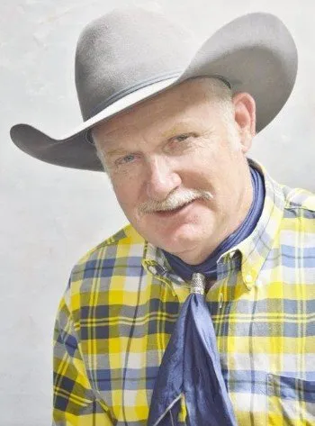

Before hibernation season sets upon us, visit with our friends from the Sternberg Museum who will bring LIVE REPTILES to our campus from 2:00 pm – 3:00 pm for your enjoyment and excitement.
Kids of all ages will be eager to visit Grace Splichal’s ART BOOTH to create a covered wagon and explore how pioneers packed for their road trips. Remember to pick up your copy of “Travel on the Trail” a learn and color booklet for the whole family.
Young and old will want to test their skill at the inflatable AX THROWING game sponsored by The Fort.
In honor of summer’s best, we have included WATER EVENTS – water gun fights, a water balloon sling shot, and panning for gold, all sponsored in part by Classic Quality Body Shop and Orscheln’s.
Don’t forget to purchase your GUN RAFFLE TICKETS either at the event or before from any Board Member, call our office 785-628-2624 or go online at director@echshays.org Two winners will be drawn from the hopper at 4:00 pm for the prizes of a Henry Big Boy Steel Rifle and an Uberti 1873 Cattleman Pistol.
As your tan lines fade and summer waves goodbye, help us close with an afternoon of BIG BANG family fun!
A special THANK YOU to our Board of Trustees and our many volunteers who are dedicated to our vision of SAVING OUR PAST’S FUTURE!

